Kotlin Programming
Lambda Expressions — Exercises 1–3

Exercise 1: Build Your Own Higher-Order Function

Task
Write a function processList that takes a list of integers and a lambda (Int) -> Boolean, and returns a new list containing only the elements that satisfy the predicate.

Function Signature
fun processList(
numbers: List<Int>,
predicate: (Int) -> Boolean
): List<Int> {
// your code here
}

Solution & Explanation
The function loops through every number in the list, runs the lambda (predicate) on each one, and only keeps numbers where the predicate returns true. This is essentially a manual implementation of Kotlin's built-in .filter() function.

fun processList(
numbers: List<Int>,
predicate: (Int) -> Boolean
): List<Int> {
val result = mutableListOf<Int>()
for (number in numbers) {
if (predicate(number)) { // run the lambda test
result.add(number) // keep if it passes
}
}
return result
}

fun main() {
val nums = listOf(1, 2, 3, 4, 5, 6)
val even = processList(nums) { it % 2 == 0 }
println(even) // [2, 4, 6]
}

Step-by-Step Breakdown
- Loop through every number in the list.
- Run the lambda predicate on each number — it returns true or false.
- If true → add to result list. If false → skip.
- Return the filtered list.

The test lambda { it % 2 == 0 } checks if a number is even (remainder when divided by 2 equals 0), so 2, 4, and 6 pass while 1, 3, and 5 are excluded.

Output Screenshot
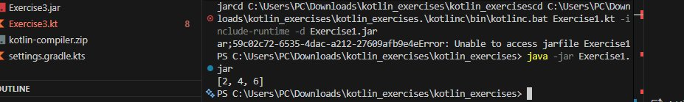
Output: [2, 4, 6] — only even numbers from the original list are returned.

Exercise 2: Transforming Between Collection Types

Task
Given a list of strings, create a map where the keys are the strings and the values are their lengths. Then print only the entries where the length is greater than 4.

Sample Data
val words = listOf("apple", "cat", "banana", "dog", "elephant")

Solution & Explanation
This exercise chains three operations: associateWith to build the map, filter to keep only long words, and forEach to print results. The key Kotlin function here is associateWith, which transforms a list into a map where each element becomes a key and the lambda produces the value.

fun main() {
val words = listOf("apple", "cat", "banana", "dog", "elephant")

words
.associateWith { it.length } // Map<String, Int>
.filter { it.value > 4 } // keep length > 4
.forEach { (word, length) -> // print each
println("$word has length $length")
}
}

Step-by-Step Breakdown
- .associateWith { it.length } — converts the list into a map: {apple=5, cat=3, banana=6, dog=3, elephant=8}
- .filter { it.value > 4 } — keeps only entries where the value (length) is more than 4, removing "cat" and "dog".
- .forEach { (word, length) -> ... } — destructures each map entry and prints it.

Output Screenshot
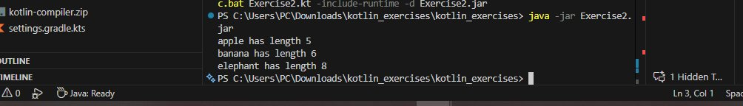
Output: apple (5), banana (6), elephant (8) — words with more than 4 characters. Note: "elephant" has 8 letters, not 7 as stated in the exercise — the expected output contained a typo.

Exercise 3: Complex Data Processing

Task
Given a list of Person objects with names and ages, find the average age of people whose names start with the letter 'A' or 'B'. Print the result rounded to one decimal place.

Data Class & Sample Data
data class Person(val name: String, val age: Int)

val people = listOf(
Person("Alice", 25),
Person("Bob", 30),
Person("Charlie", 35),
Person("Anna", 22),
Person("Ben", 28)
)

Solution & Explanation
This exercise combines filtering on object properties, extracting a specific field with map, and using the built-in average() function. The four steps map directly to the chain of operations below.

data class Person(val name: String, val age: Int)

fun main() {
val people = listOf(
Person("Alice", 25), Person("Bob", 30),
Person("Charlie", 35), Person("Anna", 22), Person("Ben", 28)
)

val average = people
.filter { it.name.startsWith('A') || it.name.startsWith('B') }
.map { it.age }
.average()

println("Average age: ${"%.1f".format(average)}")
}

Step-by-Step Breakdown
- filter { it.name.startsWith('A') || it.name.startsWith('B') } — keeps Alice, Bob, Anna, Ben. Charlie is excluded.
- .map { it.age } — extracts just the ages: [25, 30, 22, 28].
- .average() — calculates the mean: (25 + 30 + 22 + 28) / 4 = 26.25.
- "%.1f".format(average) — formats to one decimal place: 26.3.

Output Screenshot
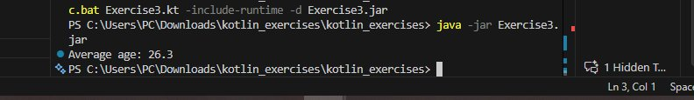
Output: Average age: 26.3 — the average age of Alice (25), Bob (30), Anna (22), and Ben (28).

